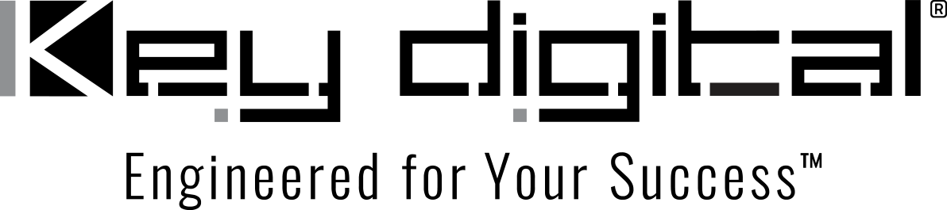

Contacts:

Key Digital

Masha Lakhter, COO

917.701.3238

masha@keydigital.com

Clyne Media, Inc.

Frank Wells, Senior Account Manager

615.585.0597

frank.wells@clynemedia.com

Key Digital to Exhibit at Innovate AV Technology Showcase Trade Show in Scottsdale, AZ

— Key Digital will demonstrate its comprehensive line of unified communications and collaboration, AV over IP, digital video processing, switcher, connectivity and control solutions during the Phoenix-area trade event —

MOUNT VERNON, NY, May 16, 2022 – Key Digital, an award-winning developer and manufacturer of leading-edge digital video processing and video signal distribution solutions, will be exhibiting at the Innovate AV Technology Showcase, a free, one-day trade event being held Wednesday, May 25, at the Phoenix-area Embassy Suites by Hilton Scottsdale Resort in Scottsdale, AZ.

Key Digital personnel will be on hand during Innovate AV to demonstrate and discuss its comprehensive range of unified communications and collaboration, AV over IP, digital video processing, switcher, connectivity and control solutions that deliver industry-leading quality, performance, and reliability for corporate, bar and restaurant, digital signage, education, government, and house-of-worship applications.

Innovate AV is a production of Ford AV, bringing the latest AV technology together in one location for exploration by facility managers, technicians, operators and other AV professionals working in video conferencing, interactive AV, digital signage and video walls, integrated control systems, and related specialties. Registration is free and includes lunch.

Innovate AV Technology Showcase free registration: https://www.fordav.com/showcase/

For more information:
Key Digital
…ends 165 words

Photo File 1: InnovateAV-2022.jpg
Photo Caption 1: Key Digital will demonstrate its comprehensive range of unified communications and collaboration, AV over IP, digital video processing, switcher, connectivity and control solutions during the Innovate AV Technology Showcase May 25, 2022

Photo File 2: KD_Logo.jpg
Photo Caption 2: Key Digital will demonstrate its comprehensive range of unified communications and collaboration, AV over IP, digital video processing, switcher, connectivity and control solutions during the Innovate AV Technology Showcase May 25, 2022

About Key Digital:
Established in 1999, Key Digital® designs and engineers intuitive digital A/V connectivity and control solutions that embody excellence. Key Digital delivers reliable, superior-quality, easily-implemented, versatile, high-performance products for corporate, education, government, house-of-worship, bar & restaurant, digital signage and residential A/V applications.

Founded by innovator Mike Tsinberg, holder of over 40 digital video and HDTV patents, Key Digital designs and engineers its products in-house at its USA headquarters in Mount Vernon, New York. The result of meticulous research, development and testing, Key Digital products showcase the company’s extensive, unparalleled technical knowledge and expertise, as well as its market-driven approach, serving as a partner to consultants, designers, and system integration firms in the A/V industry. Key Digital works as its clients’ extended engineering team, developing customized solutions for specific applications. Key Digital is an lnfoComm, CEDIA, CES, and NAHB award-winning manufacturer.

Key Digital, Engineered For Your Success™

For more information, visit our webpage at www.keydigital.com.

Follow Key Digital on social media:

