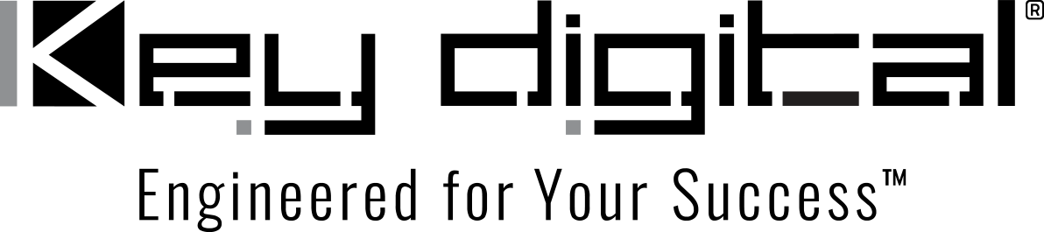

Contacts:

Key Digital

Masha Lakhter, COO

917.701.3238

masha@keydigital.com

Clyne Media, Inc.

Frank Wells, Senior Account Manager

615.585.0597

frank.wells@clynemedia.com

Key Digital® extends functionality of KD-App and KDMS Pro control software

— The KD-App for iOS and KDMS™ Pro for Windows, both available for free download, now feature additional cable and satellite system source selection control and enhanced operational capabilities and simplicity —

MOUNT VERNON, NY, April 24, 2023 – Key Digital®, award-winning developer and manufacturer of leading-edge digital video processing and video signal distribution solutions, announces extensions to the capabilities of the iOS KD-App system controller, as well as to KDMS™ Pro Windows PC management software, both expanding the third-party device control capabilities and core functionality of the free software controllers.

“To better serve our customers in the USA where Fios and Spectrum cable systems are prevalent,” shares Key Digital VP of Product Education & Experience Jonathon Ferry, “KD-App can now directly control the Cisco DTS and Arris VMS cable boxes used by those systems. Dish network subscribers nationwide can also now control Dish satellite TV control boxes natively from KD-App for channel selection.” For simplified channel switching, KD-App now also features a new direct numerical keypad.

These additions build on the extended source control capabilities of the app, which recently added Samsung Professional and Philips Professional display control for AVoIP switchers, KD-MLV4x4Pro and KD-VW4x4ProK matrix switcher control support and refined KD-CX800 control-over-IP interface support as an AVoIP matrix controller. “The KD-App’s ability to scan and find connected Key Digital hardware on a shared IP control network and automatically open the corresponding control pages is a popular feature with our customers for making it easy to configure a new system without programming, and to incorporate new hardware in an existing system,” says Ferry. “This capability has been further extended to include the KD-MLV4x4Pro and KD-VW4x4ProK matrix switchers.”

For Windows PCs, KDMS Pro for system configuration and management now has mosaic video wall control properties settings for Key Digital AVoIP switchers, along with independent video wall control display within the software. For the KD-CX800, KDMS Pro now adds occupancy sensor support within the KD Plug & Present™ ecosystem. The KDMS AVoIP System Builder and Editor tools are also improved for greater ease of system configuration.

Similar to the KD-App enhancements, KDMS Pro now supports Samsung Professional and Philips Professional display and KD-MLV4x4Pro control along with Dish Network, Cisco DTS and Arris VMS source control. KDMS Pro also features an improved main menu and ribbon control. “A new, faster and more reliable scanning mechanism has been implemented with KDMS Pro that reads the AVoIP system configuration from all KD-IP822/922/1022 devices, including the new -II upgraded encoders and decoders,” says Ferry.

Additional KDMS Pro improvements include a new interface for setting In/Out names inside the Properties window (which now allows the use of non-ASCII characters when reading names from connected Key Digital devices), reboot command capability for controllable devices after changing IP parameters, and improved communication with KD-MLV4x4Pro and KD-VW4x4ProK matrix switchers.

“The control capabilities of KD-App are typically all that our customers need for elegant, comprehensive control of Key Digital systems and a host of third-party devices, untethered and operator-friendly,” says DeWayne Rains, Key Digital VP of Sales. “Both KD-App and KDMS Pro provide system setup and control without programming and deliver amazing ease-of-use for end users who can discard their IR remotes and control their systems from customized UIs tailored to their needs. That Key Digital provides this capability for free is unparalleled in the marketplace.”

KD-App is available for free download by searching for “Key Digital” in the Apple App Store and includes a demo mode. KDMS Pro is available for free download from the Key Digital web site.

Links:
Key Digital
KDMS™ Pro info and download
KD-App info
…ends 556 words

Photo file 1: KD-App_screens.jpg
Photo caption 1: The free Key Digital iOS KD-App provides a programming-free user interface for controlling networked Key Digital app-ready devices and an expanding range of third-party hardware.

Photo file 2: KDMS-Pro.jpg
Photo caption 2: Key Digital’s free KDMS Pro Windows PC software provides programming-free AV system setup and control.

Photo file 3: KDMS-Pro-Screen_VideoWall_setup.jpg
Photo caption 3: Key Digital’s free KDMS Pro Windows PC software provides programming-free AV system setup and control.

About Key Digital:
Established in 1999, Key Digital® designs and engineers intuitive digital A/V connectivity and control solutions that embody excellence. Key Digital delivers reliable, superior-quality, easily-implemented, versatile, high-performance products for corporate, education, government, house-of-worship, bar & restaurant, digital signage and residential A/V applications.

Founded by innovator Mike Tsinberg, holder of over 40 digital video and HDTV patents, Key Digital designs and engineers its products in-house at its USA headquarters in Mount Vernon, New York. The result of meticulous research, development and testing, Key Digital products showcase the company’s extensive, unparalleled technical knowledge and expertise, as well as its market-driven approach, serving as a partner to consultants, designers, and system integration firms in the A/V industry. Key Digital works as its clients’ extended engineering team, developing customized solutions for specific applications. Key Digital is an lnfoComm, CEDIA, CES, and NAHB award-winning manufacturer.

Key Digital, Engineered For Your Success™

For more information, visit our webpage at www.keydigital.com.

Follow Key Digital on social media:

