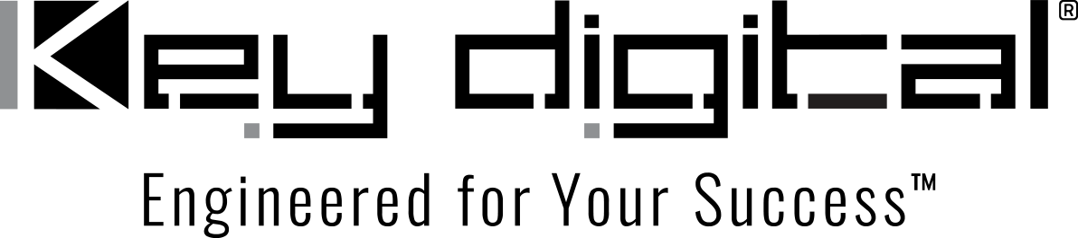

Contacts:

Key Digital

Masha Lakhter, COO

917.701.3238

masha@keydigital.com

Clyne Media, Inc.

Frank Wells, Senior Account Manager

615.585.0597

frank.wells@clynemedia.com

Key Digital to Exhibit at cavlo Trade Show in Nashville

— Key Digital will demonstrate its comprehensive line of AV over IP, presentation, digital video processing, switcher and connectivity solutions during the Nashville-area trade event —

MOUNT VERNON, NY, April 5, 2022 – Key Digital, an award-winning developer and manufacturer of leading-edge digital video processing and video signal distribution solutions, will be exhibiting at cavlo Nashville, a trade-only, one-day event being held Wednesday, May 11, at the The Embassy Suites Nashville South Cool Springs Hotel in Franklin, Tennessee (just south of Nashville).

Key Digital personnel will be on hand during cavlo Nashville to demonstrate and discuss its comprehensive range of AV over IP, presentation, digital video processing, switcher and connectivity solutions that deliver industry-leading quality, performance, and reliability for corporate, bar and restaurant, digital signage, education, government, and house-of-worship applications.

cavlo Nashville, “The Trade Show for the Rest of US!”, is focused on professionals from the commercial entertainment and communication fields: equipment specifiers, system integrators, event engineers, technicians and end users from the hospitality, corporate, education or worship fields. Registration for the event is free.

cavlo Nashville events begin with a reception the evening of May 10, followed by a full day of exhibits and educational sessions on May 11.

cavlo Nashville free registration: https://brushfire.com/cavlo/cavlo-2022/529638

For more information:
Key Digital
…ends 177 words

Photo File 1: cavlo-TN.jpg
Photo Caption 1: Key Digital will demonstrate its comprehensive line of AV over IP, presentation, digital video processing, switcher and connectivity solutions during cavlo Nashville, May 11, 2022

About Key Digital:
Established in 1999, Key Digital® designs and engineers intuitive digital A/V connectivity and control solutions that embody excellence. Key Digital delivers reliable, superior-quality, easily-implemented, versatile, high-performance products for corporate, education, government, house-of-worship, bar & restaurant, digital signage and residential A/V applications.

Founded by innovator Mike Tsinberg, holder of over 40 digital video and HDTV patents, Key Digital designs and engineers its products in-house at its USA headquarters in Mount Vernon, New York. The result of meticulous research, development and testing, Key Digital products showcase the company’s extensive, unparalleled technical knowledge and expertise, as well as its market-driven approach, serving as a partner to consultants, designers, and system integration firms in the A/V industry. Key Digital works as its clients’ extended engineering team, developing customized solutions for specific applications. Key Digital is an lnfoComm, CEDIA, CES, and NAHB award-winning manufacturer.

Key Digital, Engineered For Your Success™

For more information, visit our webpage at www.keydigital.com.

Follow Key Digital on social media:

