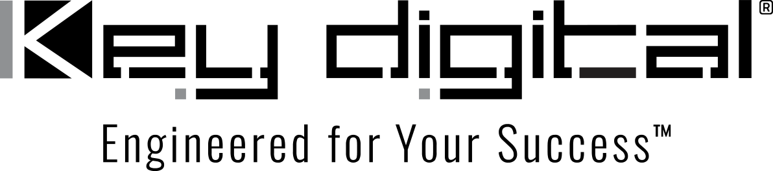

Contacts:

Key Digital

Masha Lakhter, COO

917.701.3238

masha@keydigital.com

Clyne Media, Inc.

Frank Wells, Senior Account Manager

615.585.0597

frank.wells@clynemedia.com

Suffern Central School District Employs Key Digital Solutions for Its Conference/Training Room

— Products including the KD-MC1000 Master Controller and the KDPlay™-enabled KD-BYOD4K wireless presentation gateway let school officials and visiting presenters easily operate and interface with a new video wall —

MOUNT VERNON, NY, April 27, 2022 – A newly installed video wall at the Suffern Central School District’s head office in Hillburn, NY, allows the organization’s leadership and visiting presenters to input a wide range of AV sources during meetings and presentations. The wall, comprising a dozen 55-inch flat-panel displays in a 3x4 configuration, offers crystal-clear imaging for the office’s conference and training room. But it’s what participants don’t see that really makes the difference: an array of products from Key Digital that make up the infrastructure for the video wall, installed and integrated by West Park, NY-based systems integrator Absolute Connections, which also designed and installed the video wall itself.

“The Key Digital products were the perfect fit for this project,” states Yass Chamas, Vice President and Co-Owner of Absolute Connections, which specializes in AV systems design and integration for the education sector. He cites certain items in particular as making the conference/training room a success, including the KD-WP8 8-Button Web UI Programmable IP Control Wall Plate Keypad with PoE, interfacing with the KD-MC1000 Master Controller – with multi-brand system device control via the Compass Control® Pro iOS app – establishing a wired/LAN network supporting up to eight ports with a fully integrated control system. “Any user can easily turn the entire videowall on or off and input content into it,” he explains. Further contributing to the ease of inputting content for presentations, Absolute Connections also installed Key Digital KDPlay™ components, including a KD-BYOD4K wireless presentation gateway, which enables presenters to cast content to their display or projector from their Windows or Mac laptops and iOS/Android/Chromecast devices. A KD-Pro4x1X HDMI Switcher allows them to move seamlessly between multiple additional content sources. Other Key Digital system elements include the KD-EXWPSTx single-gang wall-plate transmitter + presentation switcher, with one HDMI and one USB-C input; the EX18GR 4K UHDoTP (Ultra High Definition over Twisted Pair) HDMI Extender Tx + Rx Kit; and the KD-AMP220 Class D 2-Channel Amplifier.

“Everything works together perfectly, making it easy to operate by the staff and presenters using the room,” says Chamas. “In fact, that has been where the compliments the system has received are focused on: things look good and sound good, but it’s very important that people be able to access the videowall and system easily and without a lot of training. Press a button and it’s on and ready to go. That’s what Key Digital helped us accomplish.”

For more information:
Key Digital
…ends 400 words

Photo File 1: Suffern_Video_Wall.jpg
Photo Caption 1: The newly installed video wall at Suffern Central School District is enabled by an all Key Digital infrastructure

Photo File 2: Suffern_WP8.jpg
Photo Caption 2: The Key Digital KD-WP8 8-Button Web UI Programmable IP Control Wall Plate Keypad makes it easy to control Suffern Central School District’s new video wall

Photo File 3: Suffern_AV_Rack.jpg
Photo Caption 3: Key Digital KD-MC1000 master control units provide integrated control of the Suffern Central School District’s AV system from a KD-WP8 wall plate controller and from iOS devices running the Key Digital Compass Control Pro app, with a KD-Pro4x1X switcher and top mounted KD-BYOD4K wireless presentation gateway providing source control and WiFi content casting

About Key Digital:
Established in 1999, Key Digital® designs and engineers intuitive digital A/V connectivity and control solutions that embody excellence. Key Digital delivers reliable, superior-quality, easily-implemented, versatile, high-performance products for corporate, education, government, house-of-worship, bar & restaurant, digital signage and residential A/V applications.

Founded by innovator Mike Tsinberg, holder of over 40 digital video and HDTV patents, Key Digital designs and engineers its products in-house at its USA headquarters in Mount Vernon, New York. The result of meticulous research, development and testing, Key Digital products showcase the company’s extensive, unparalleled technical knowledge and expertise, as well as its market-driven approach, serving as a partner to consultants, designers, and system integration firms in the A/V industry. Key Digital works as its clients’ extended engineering team, developing customized solutions for specific applications. Key Digital is an lnfoComm, CEDIA, CES, and NAHB award-winning manufacturer.

Key Digital, Engineered For Your Success™

For more information, visit our webpage at www.keydigital.com.

Follow Key Digital on social media:

